Findings were reported to repository maintainers on September 09, 2026; issue #32 is still open as of this draft, September 22, 2026. uci-ml-repo/ucimlrepo https://github.com/uci-ml-repo/ucimlrepo/issues/32
Still open as of September 30, 2026, with no comments.

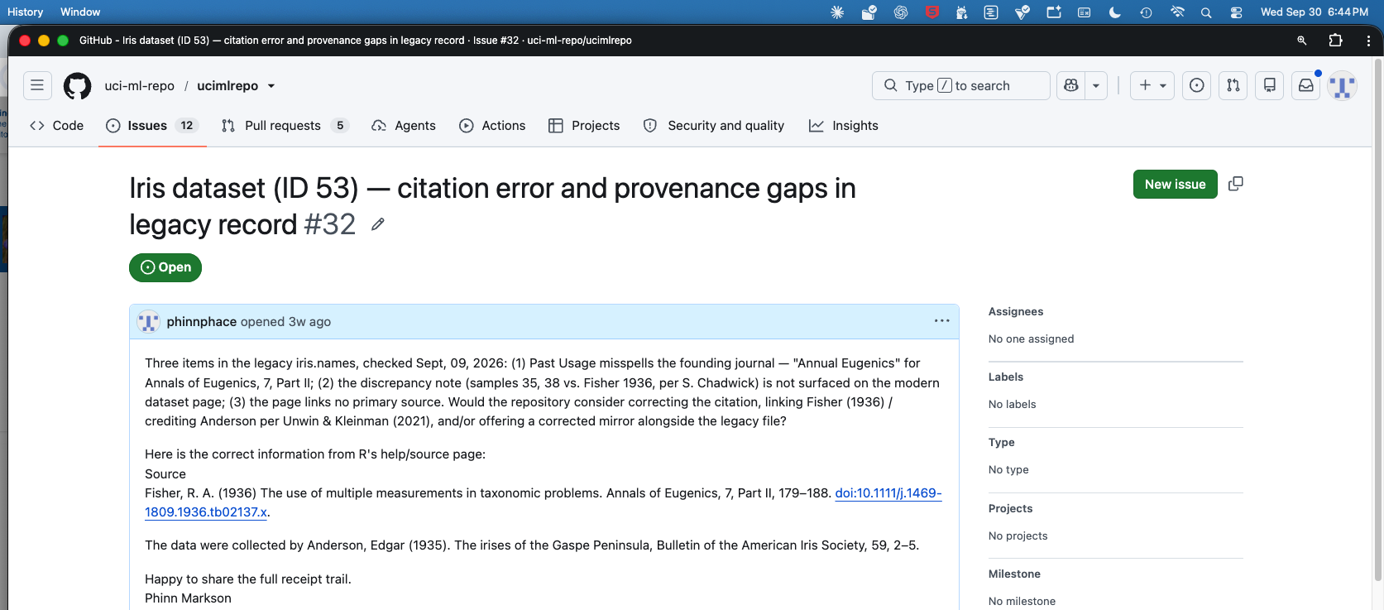
Receipts dated September 30, 2026: full outputs in the accompanying receipt file.

